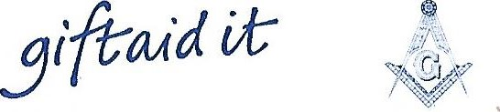
Province of Down Masonic Charities
Registered with the Charity Commission for Northern Ireland
Bangor DCC NIC100739 Banbridge DCC NIC101801
Downpatrick DCC NIC101336 Newry DCC NIC101882
Newtownards DCC NIC101729 United MCC NIC101757

CHARITY GIFT AID DECLARATION
I authorise the receiving District Masonic
Charity Committee to treat this donation:
£ . as Gift Aid
I am a UK taxpayer and understand that if I pay less Income Tax and / or Capital Gains Tax in the current year than the amount of Gift Aid claimed on all my donations it is my responsibility to pay the difference.
Boost your donation by 25p of Gift Aid for every £1 you donate.
Gift Aid is reclaimed by the charity from the tax you pay for the current tax year. Your address is needed to identify you as a current UK taxpayer.
Date .
ALL DETAILS TO BE COMPLETED IN BLOCK CAPITALS
Forename: .
Surname: .
House No. .
Address: .
.
Post Code: .
Signature: .
This donation will be created to the host lodge and processed
Via the appropriate Registered Charity Committee listed above

